DELICIOUS

Group members:

Ahson Junani – SCM030139

Rezwan – SCM024522

Avinesh Selvaraj – SCM031268

Submitted to: Dr. Ashley

**Table of Contents**

Use Case Diagram 4

Class Diagram 5

Activity diagram for Login 6

Activity diagram for reservation 7

Activity diagram for ordering food for delivery 8

Entity relationship diagram 9

# Use Case Diagram

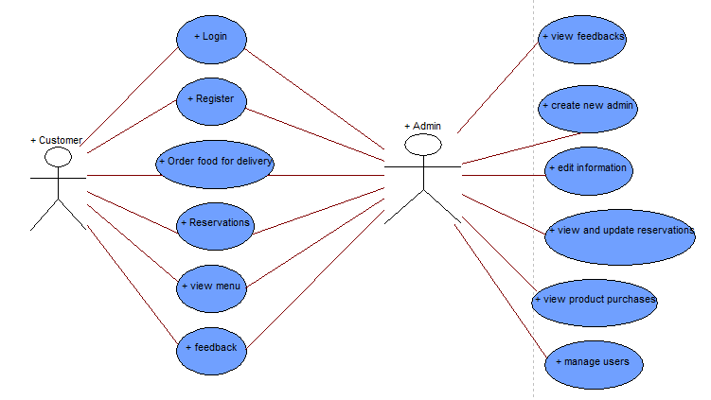

The use case diagram shows that the customers can have access to only certain features of the website while the admin have full control of the website.

# Class Diagram

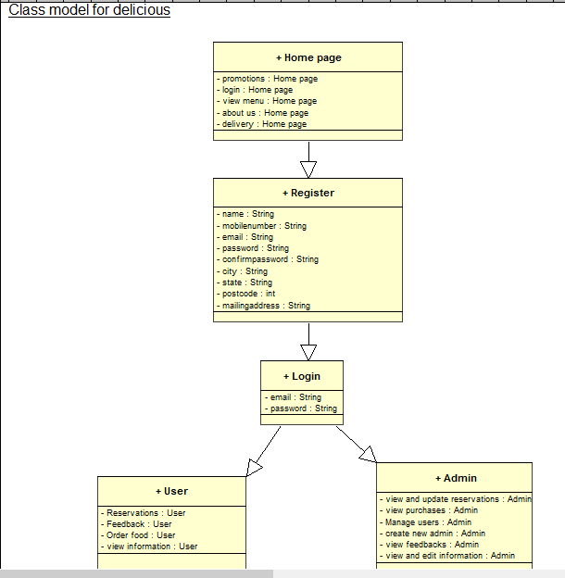

The class diagram shown above gives a clearer description of the website. The homepage contains the sections of login, menu, delivery, about us and the promotions. If the customer wants to order food, he or she must register first and then login to order food or make reservations.

The users can order food, view the information on the website, give their feedbacks and make reservations.

The admin have the full control of the website. They can view and update all the information and reservations. Can check on the purchases made by company, manage the users and admin and view the feedbacks by customers.

# Activity diagram for Login

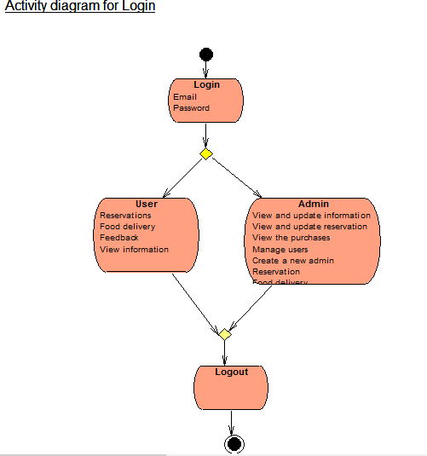

To login the user or the admin needs to enter their username and password. The diagram above shows what features of the website are available for the respective user.

# Activity diagram for reservation

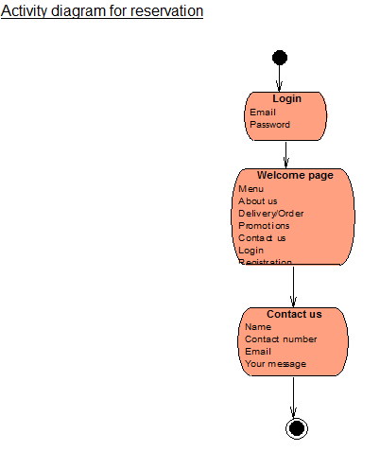

To make a reservation, a user must login. After login, the user will see a welcome page. From the welcome page, they can navigate to contact us page. At contact us page they can see our email, contact number and a message box to enter their message whether they want to make a reservation or a complaint or feedback.

# Activity diagram for ordering food for delivery

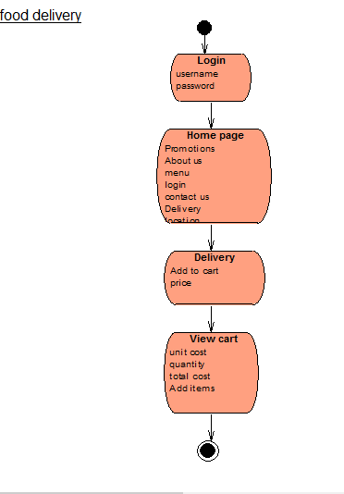

For ordering food, customer need to login first. After login, they will see a home page. From there they can easily navigate to the delivery page. On delivery page, they can see the menu, price and the option to add item to their cart. When they click on add to cart, the item will be added to their cart.

# Entity relationship diagram

